OXSHOTT ROYALS FOOTBALL CLUB
MATCH DETAILS

We would like to welcome you and your team to Oxshott Royals FC. Please see the match details below.

Match: | Oxshott Royals XXX v
Date: | XXX | Kick Off Time: | XXX
Address: | Cobham Recreation Ground, Lushington Drive, Cobham KT11 2LX. Also known as Anyards Road Recreation Ground.
Manager: | XXX | Contact Telephone: | XXX
Referee: | XXX
Home Kit: | Red and White Shirts/White Shorts/Red Socks Please advise if there is a clash
Parking: | There is very limited parking available on the streets around the Rec. There is a large car park on Hollyhedge Road that is free on a Sunday.
Other Details: | No Smoking or Vaping Allowed in the vicinity of the pitch. Please keep any dogs under control.

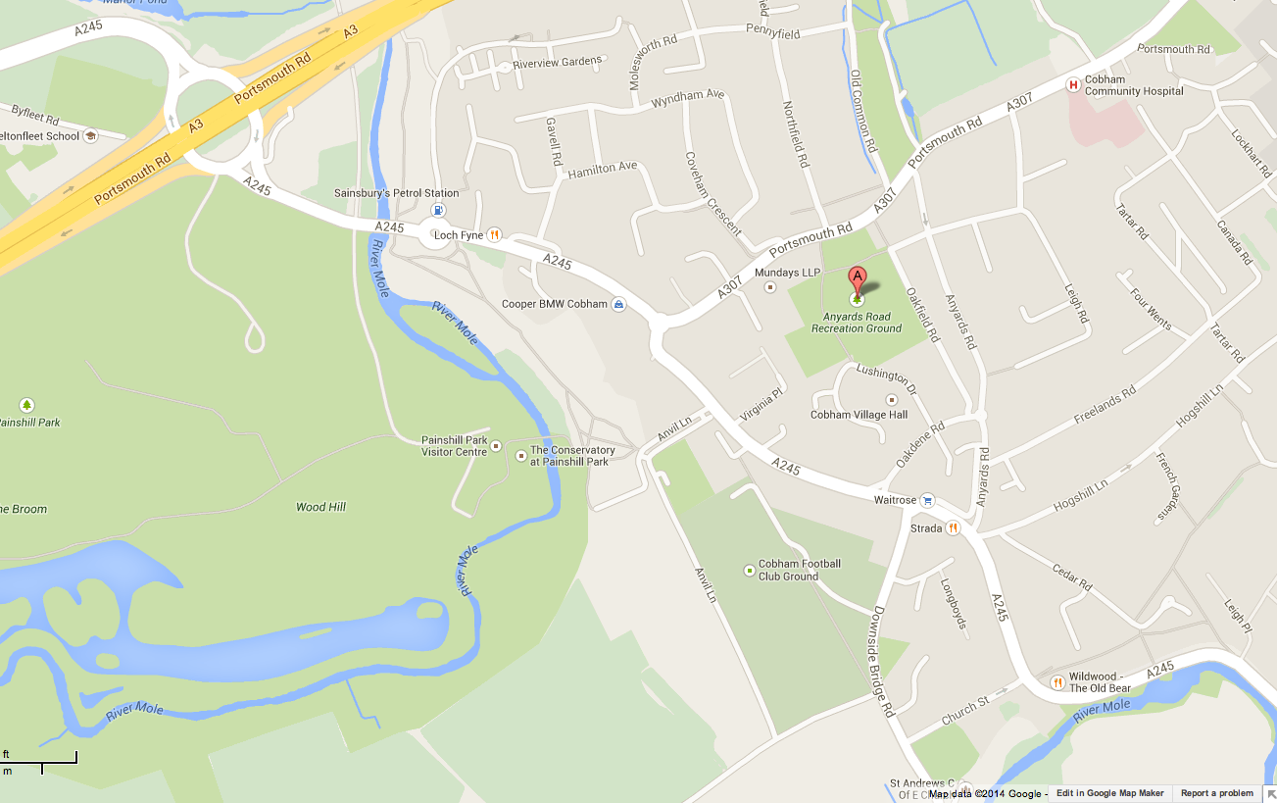

Oxshott Royals expects that all Players, Supporters, Team Managers and Officials adhere to the FA’s Respect Code of Conduct. All spectators are asked to stand behind the Respect barriers and support both the players and officials to ensure that everyone enjoys the football. The Club will not tolerate any offensive, insulting or abusive language or behaviour.

