OXSHOTT ROYALS FOOTBALL CLUB
MATCH DETAILS

We would like to welcome you and your team to Oxshott Royals FC. Please see the match details below.
Match: | Oxshott Royals XXX v
Date: | XXX | Kick Off Time: | XXX
Address: | Cobham RFC (Old Surbitonians Memorial Ground), Fairmile Lane, Cobham, Surrey KT11 2BU.
Manager: | XXX | Contact Telephone: | XXX
Referee: | XXX
Home Kit: | Red and White Shirts/White Shorts/Red Socks Please advise if there is a clash
Parking: | Please note that there is no parking available on site. Parking is available adjacent to Cobham RFC at Munro House (off Portsmouth Road).
Other Details: | AGP pitch - please note the accepted footwear: boots with plastic moulded studs, boots with plastic or rubber studs, boots with metal or metal tipped studs and synthetic turf trainers only. Please note that all spectators must remain behind the green fence surrounding the pitch.  No smoking or vaping on the site. No dogs allowed. Refreshments and facilities are available in the clubhouse.

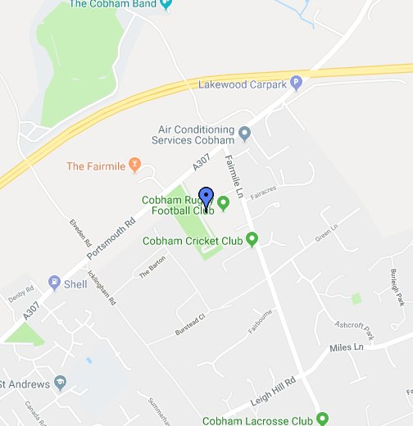

Oxshott Royals expects that all Players, Supporters, Team Managers and Officials adhere to the FA’s Respect Code of Conduct. All spectators are asked to stand behind the Respect barriers and support both the players and officials to ensure that everyone enjoys the football. The Club will not tolerate any offensive, insulting or abusive language or behaviour.

