OXSHOTT ROYALS FOOTBALL CLUB
MATCH DETAILS

We would like to welcome you and your team to Oxshott Royals FC. Please see the match details below.

Match: | Oxshott Royals XXX v
Date: | XXX | Kick Off Time: | XXX
Address: | Hautboy Meadow, Ockham Lane, Ockham GU23 6NP
Manager: | XXX | Contact Telephone: | XXX
Referee: | XXX
Home Kit: | Red and White Shirts/White Shorts/Red Socks Please advise if there is a clash
Parking: | There is limited parking available. Cars should not park on the pavement outside the Clubhouse or The Hautboy apartments. Police are likely to ticket any vehicles parked there. Parking is available along the adjacent side road but please do not block neighbours’ driveways. Please respect our neighbours and do not bash boots on the walls of the Hautboy apartments
Other Details: | Please do not warm up on ANY of the pitches, including goalmouths. No Smoking or Vaping Allowed. Refreshments are available in the Clubhouse. Please keep dogs on a lead.

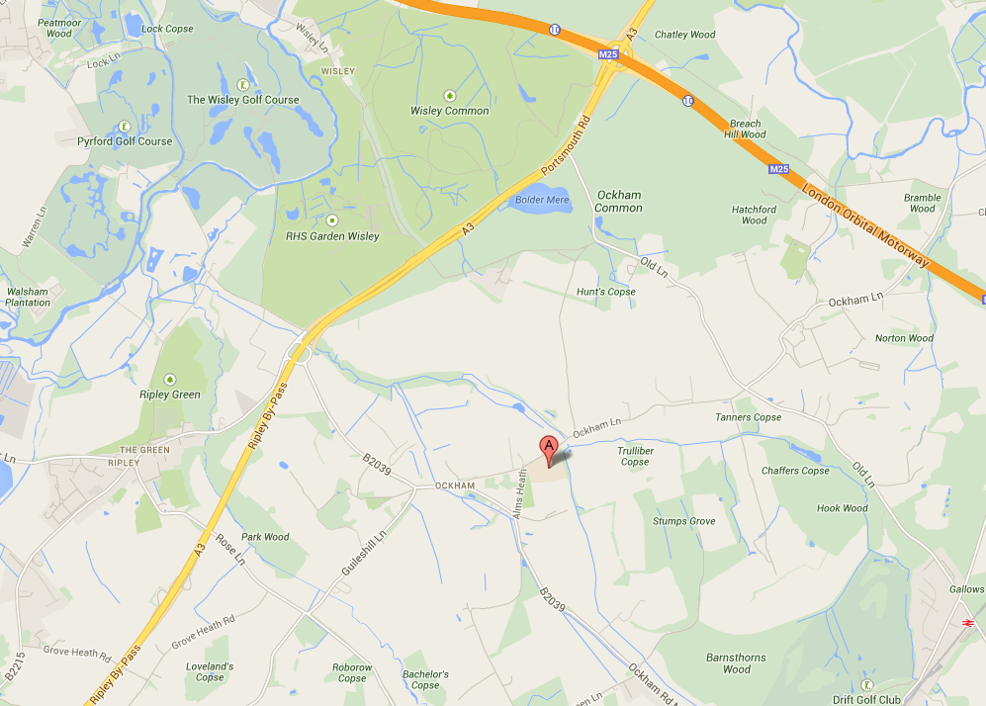

Oxshott Royals expects that all Players, Supporters, Team Managers and Officials adhere to the FA’s Respect Code of Conduct. All spectators are asked to stand behind the Respect barriers and support both the players and officials to ensure that everyone enjoys the football. The Club will not tolerate any offensive, insulting or abusive language or behaviour.

