OXSHOTT ROYALS FOOTBALL CLUB
MATCH DETAILS

We would like to welcome you and your team to Oxshott Royals FC. Please see the match details below.

Match: | Oxshott Royals XXX v
Date: | XXX | Kick Off Time: | XXX
Address: | Oxshott Village Sports Club, Steels Lane, Oxshott, KT22 0RF
Manager: | XXX | Contact Telephone: | XXX
Referee: | XXX
Home Kit: | Red and White Shirts/White Shorts/Red Socks Please advise if there is a clash
Parking: | There is very limited parking available. Please do not park down the side of the pitches. Additional parking is available at the Village Centre on nearby on Holtwood Road. Please do not block the neighbours’ drives or the pavement.
Other Details: | No smoking or vaping allowed anywhere in the ground. Tea, coffee and bacon rolls are available in the Clubhouse. No dogs allowed.

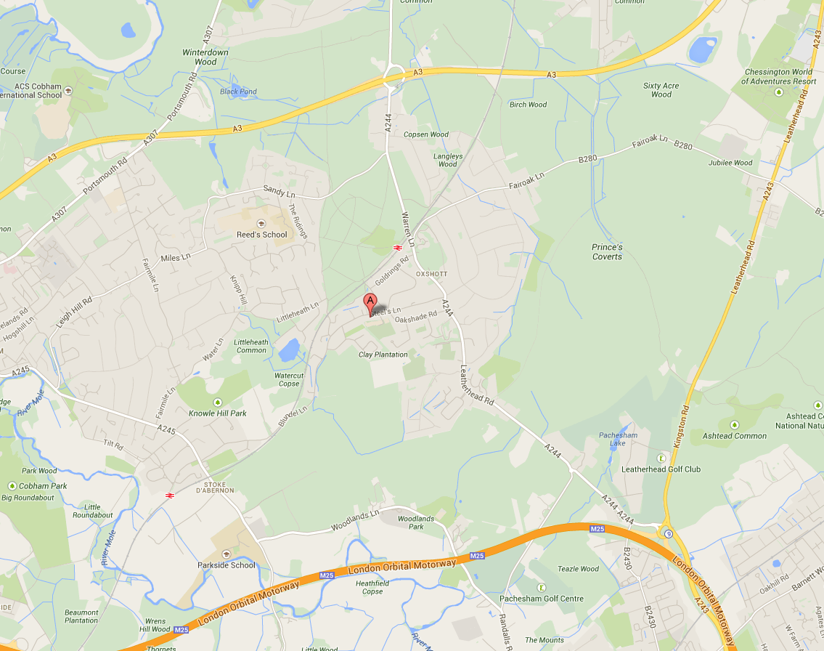

Oxshott Royals expects that all Players, Supporters, Team Managers and Officials adhere to the FA’s Respect Code of Conduct. All spectators are asked to stand behind the Respect barriers and support both the players and officials to ensure that everyone enjoys the football. The Club will not tolerate any offensive, insulting or abusive language or behaviour.

