OXSHOTT ROYALS FOOTBALL CLUB
MATCH DETAILS

We would like to welcome you and your team to Oxshott Royals FC. Please see the match details below.

Match: | Oxshott Royals XXX v
Date: | XXX | Kick Off Time: | XXX
Address: | Surrey Sports Park, University of Surrey, Richard Meyjes Road, Guildford GU2 7AD
Manager: | XXX | Contact Telephone: | XXX
Referee: | XXX
Home Kit: | Red and White Shirts/White Shorts/Red Socks Please advise if there is a clash
Parking: | There is plenty of parking on site. If you intend to stay for more than 3 hours please give your registration number to Reception.
Other Details: | Absolutely NO metal studs allowed on the 3G pitch. Boots must have moulded plastic studs or wear trainers. Please check on arrival to see if a changing room has been allocated. It must be left in the condition you find it. Games must start on time as the pitch is always booked. There is Starbucks Café on site. No smoking or dogs allowed.

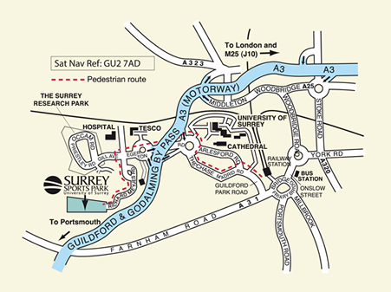
Oxshott Royals expects that all Players, Supporters, Team Managers and Officials adhere to the FA’s Respect Code of Conduct. All spectators are asked to stand behind the Respect barriers and support both the players and officials to ensure that everyone enjoys the football. The Club will not tolerate any offensive, insulting or abusive language or behaviour.

