OXSHOTT ROYALS FOOTBALL CLUB
MATCH DETAILS

We would like to welcome you and your team to Oxshott Royals FC. Please see the match details below.

Match: | Oxshott Royals XXX v
Date: | XXX | Kick Off Time: | XXX
Address: | St Andrew’s School, Lockhart Road, Cobham KT11 2AX
Manager: | XXX | Contact Telephone: | XXX
Referee: | XXX
Home Kit: | Red and White Shirts/White Shorts/Red Socks Please advise if there is a clash
Parking: | Parking is available on site.
Other Details: | No Smoking or vaping allowed. There are no toilets on site. No dogs allowed.

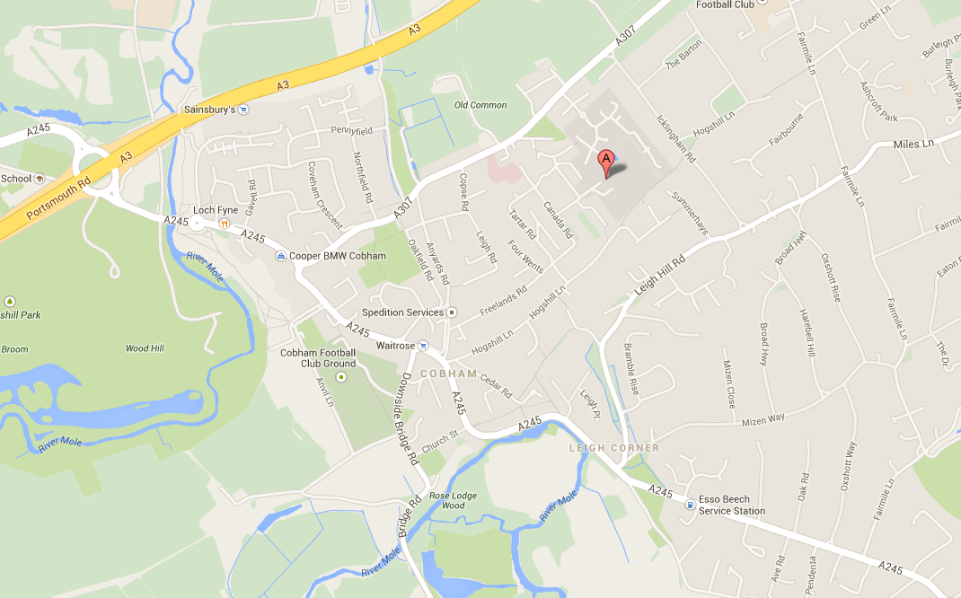

Oxshott Royals expects that all Players, Supporters, Team Managers and Officials adhere to the FA’s Respect Code of Conduct. All spectators are asked to stand behind the Respect barriers and support both the players and officials to ensure that everyone enjoys the football. The Club will not tolerate any offensive, insulting or abusive language or behaviour.

